Example workflow:

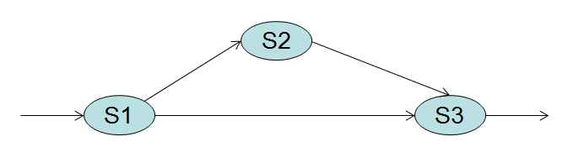

|  |  |  |  |  |  |
| --- | --- | --- | --- | --- | --- |
|  | Service | Cost ($) | Reliability(%) | Time (s) | Availability(%) |
| SC1 | S11 | 20 | 95 | 2 | 95 |
| S12 | 30 | 99 | 3 | 89 |
| S13 | 23 | 98 | 23 | 98 |
| S14 | 12 | 99 | 1 | 02 |
| S15 | 25 | 89 | 3 | 78 |
| SC2 | S21 | 12 | 70 | 3 | 70 |
| S22 | 15 | 99 | 5 | 93 |
| S23 | 53 | 96 | 8 | 96 |
| SC3 | S31 | 11 | 97 | 9 | 97 |
| S32 | 12 | 89 | 12 | 89 |
| S33 | 12 | 90 | 1 | 90 |
| S34 | 15 | 91 | 3 | 98 |
| S35 | 18 | 56 | 6 | 56 |
| S36 | 23 | 68 | 2 | 67 |
| S37 | 22 | 59 | 1 | 59 |
| S38 | 21 | 92 | 2 | 89 |

Weight of QoS parameters in calculating fitness function:

Cost (35%)

Reliability (10%)

Performance (20%)

Availability (35%)